
St. Francis Institute of Technology
(Engineering College)
An Autonomous Institute, Affiliated to University of Mumbai NAAC A+ Accredited | CMPN, EXTC, INFT NBA Accredited | ISO 9001:2015 Certified
Department of Artificial Intelligence and Machine Learning
Academic Year: 2025-2026 Term: Even (Jan. 2026 – Jun. 2026) Class / Branch: SE – AIML Semester: IV Course: Web Programming Lab. (AI4VS_LR4)
Date of Assignment: / /2026 Date of Submission: / /2026
Pre-Lab Exercises for Experiment-4
Introduction to JavaScript & Basic Interactivity
Before performing Experiment-4 (Implementing Interactivity & Event-Driven Logic using JavaScript), understand the basics of JavaScript, how it works with HTML, and how user actions trigger events.
Part A: JavaScript Basics
Exercise 1: Introduction to JavaScript
Task:
Write a short note on:
• What is JavaScript?
Ans. JavaScript is a high-level programming language used to create interactive and dynamic web pages. It helps websites respond to user actions like clicks, typing, and scrolling.

• Why is JavaScript called a client-side scripting language?
Ans. JavaScript is called a client-side scripting language because it runs directly in the user’s web browser (client side) without needing server processing.

• One real-life example of JavaScript usage in websites.
Ans. A common example is form validation, where JavaScript checks whether the user has entered correct details (like email format) before submitting the form.

Exercise 2: JavaScript Output Methods
Task: Identify the purpose of the following:
• alert()
Ans. Purpose: Displays a popup message box to the user.
Use case: Showing a welcome message or warning alert when a page loads.

• console.log()
Ans. Purpose: Displays output in the browser’s console.
Use case: Used by developers to debug and check variable values during program execution.
• document.write()
Ans. Purpose: Writes content directly into the HTML document.
Use case: Displaying simple text output on a webpage for testing or demonstration purposes.

Part B: Hands-On JavaScript Practice
Exercise 3: Writing Your First JavaScript Code
Task:
• Create an HTML file.
• Add JavaScript inside a <script> tag.
• Display a welcome message using alert() when the page loads.
CODE
<!DOCTYPE html>
<html>
<head>
<title>My First JavaScript Program</title>
</head>
<body>
<script>
alert("Welcome to JavaScript!");
</script>
</body>
</html>
OUTPUT
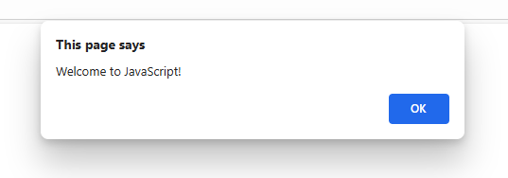

Exercise 4: Using Variables in JavaScript
Task:
• Declare variables for:
– Name
– Age
• Display the values in an alert message.
Hint: Use the let keyword
CODE
<!DOCTYPE html>
<html>
<head>
<title>Using Variables</title>
</head>
<body>
<script>
let name = "Angel X";
let age = 19;
alert("My name is " + name + " and I am " + age + " years old.");
</script>
</body>
</html>

OUTPUT
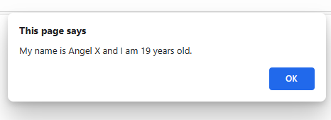

Exercise 5: JavaScript with Button Click Task:
• Create a button labeled “Click Me”.
• When clicked, display a message using JavaScript.

CODE
<!DOCTYPE html>
<html>
<head>
<title>Button Click Example</title>
</head>
<body>
<button onclick="showMessage()">Click Me</button>
<script>
function showMessage() {
alert("Button was clicked!");
}
</script>
</body>
</html>

OUTPUT
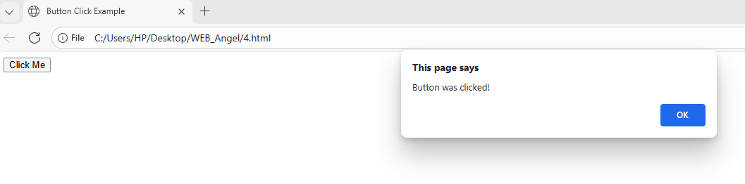
Part C: Introduction to Events
Exercise 6: Understanding Events Task: Answer the following:
• What is an event in JavaScript?
Ans. An event in JavaScript is an action that occurs in the browser, either by the user (like clicking or typing) or by the system (like page loading).

• List any three common JavaScript events.
Ans. 1. Onclick 2. Onmouseover 3. Onkeydown

• Which event occurs when a button is clicked?
Ans. The event that occurs when a button is clicked is onclick.

Exercise 7: Event Handling Using onclick
Task:
• Create a button.
• Use the onclick attribute to:
– Change the text of a paragraph.
CODE
<!DOCTYPE html>
<html>
<head>
<title>Event Handling Example</title>
</head>
<body>
<p id="demo">Angel Xavier</p>
<button onclick="changeText()">Change Text</button>
<script>
function changeText() {
document.getElementById("demo").innerHTML = "Jaden!";
}
</script>
</body>
</html>
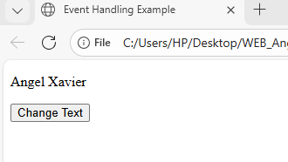
OUTPUT
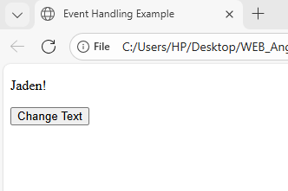
Part D: Basic DOM Manipulation
Exercise 8: Accessing HTML Elements Task:
• Create a paragraph with an id.
• Use JavaScript to:
– Change its text content on button click.

CODE
<!DOCTYPE html>
<html>
<head>
<title>Accessing HTML Elements</title>
</head>
<body>
<p id="para">Hello Students</p>
<button onclick="changeContent()">Change Text</button>
<script>
function changeContent() {
document.getElementById("para").innerHTML = "Text Modified Successfully!";
}
</script>
</body>
</html>
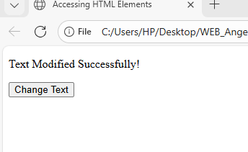
OUTPUT
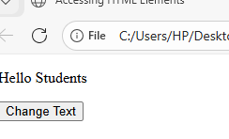

Exercise 9: Simple Logic Using JavaScript
Task:
• Create a button.
• When clicked:
– Display “Good Morning” before 12 PM – Display “Good Evening” after 12 PM

CODE
<!DOCTYPE html>
<html>
<head>
<title>Greeting Example</title>
</head>
<body>
<button onclick="greetUser()">Greet Me</button>
<script>
function greetUser() {
let time = new Date().getHours();
if (time < 12) {
alert("Good Morning");
} else {
alert("Good Evening");
}
}
</script>
</body>
</html>
OUTPUT
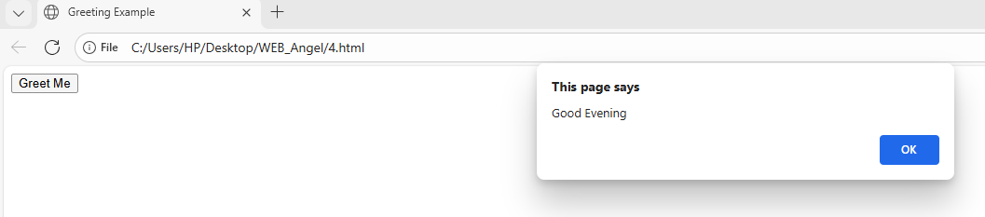

Part E: Practice Questions (Short Answer)
• Difference between HTML and JavaScript?
Ans. HTML is used to structure and design the content of a webpage, while JavaScript is used to add interactivity and dynamic behavior to the webpage.
• What is an event?
Ans. An event is an action performed by the user or browser, such as clicking a button, typing on the keyboard, or loading a page.
• What is DOM?
Ans. DOM (Document Object Model) is a programming interface that allows JavaScript to access, modify, and manipulate HTML elements.

• Why is JavaScript important for interactivity?
Ans. JavaScript allows web pages to respond to user actions, validate forms, update content dynamically, and improve user experience.
• What happens if JavaScript is disabled in the browser?
Ans. Interactive features like form validation, popups, animations, and dynamic updates will not work properly.

